Unit 3 SQL Aggregates and Groupings

**Corey Crooks**

**Purdue University Global**

**IT350 – Advanced Database Concepts**

**Jason Johnson**

**February 22nd, 2023**

**Problem 1:** Establish a database view called TotalBikesSoldView that lists each bike name and associated total quantity sold. Then query the view to show the top ten bikes sold. Present the output in descending order based on total bikes sold.

USE BikeStores

CREATE VIEW TotalBikesSoldView AS

SELECT product_name, SUM(quantity) AS "Total Sold"

FROM Production.Products PR

INNER JOIN Sales.Order_Items OI

ON PR.product_id = OI.product_id

GROUP BY product_name;

SELECT TOP 10 * FROM TotalBikesSoldView

ORDER BY "Total Sold" DESC;

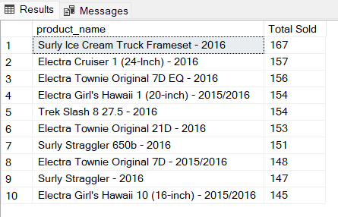

**Problem 2:** Establish a database view called **MaximumBrandBikePriceView** that lists each bike brand and associated maximum bike price. Then query the view and present the output in ascending order based on the bike brand name.

USE BikeStores

CREATE VIEW MaximumBrandBikePriceView AS

SELECT brand_name, MAX(list_price) AS MaxPrice

FROM Production.Products PR INNER JOIN Production.Brands BR

ON PR.brand_id = BR.brand_id

GROUP BY brand_name;

SELECT * FROM MaximumBrandBikePriceView

ORDER BY brand_name;

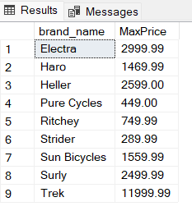

**Problem 3:** Establish a database view called **AverageBrandBikePriceView** that lists each bike brand name and associated average bike list price and list price standard deviation. Then query the view and present the output in ascending order based on the bike brand name.

USE BikeStores

CREATE VIEW AverageBrandBikePriceView AS

SELECT brand_name, AVG(list_price) AS AvgPrice,

STDEV(list_price) AS StdDevPrice

FROM Production.Products PR INNER JOIN Production.Brands BR

ON PR.brand_id = BR.brand_id

GROUP BY brand_name;

SELECT * FROM AverageBrandBikePriceView

ORDER BY brand_name;

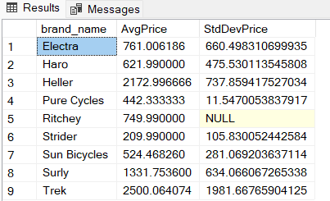

**Problem 4:** Establish a database view called **NumberOfCustomersPerStateView** that lists the number of customers in each state. The view needs to show the state name along with the customer amount. Then query the view and present the output in ascending order based on state.

USE BikeStores

CREATE VIEW NumberOfCustomersPerStateView AS

SELECT state, COUNT(*) NumCustomers

FROM Sales.customers

GROUP BY state;

SELECT * FROM NumberOfCustomersPerStateView

ORDER BY state;

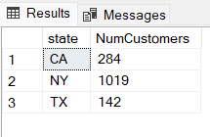

**Problem 5:** Establish a database view called **TotalBikesSoldPerStateView** that shows the cumulative bike sales per state. The view needs to show the state name along with the bike sales quantity. Then query the view and present the output in ascending order based on state.

USE BikeStores

CREATE VIEW TotalBikesSoldPerStateView AS

SELECT state, SUM(quantity) AS NumBikesSold

FROM Sales.customers C INNER JOIN Sales.orders O

ON C.customer_id = O.order_id

INNER JOIN Sales.order_items OI

ON O.order_id = OI.order_id

GROUP BY state;

SELECT * FROM TotalBikesSoldPerStateView

ORDER BY state;

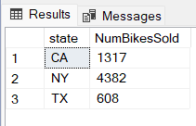

**Problem 6:**Create a stored procedure that lists the stock quantity at each store for a specified bike brand. The output must show the store name and stock quantity value. The results need to be presented in ascending order based on the store name. The skeleton of the stored procedure is provided below.

USE BikeStores

CREATE PROCEDURE GetStoreBrandStockQuantity

@BrandName VARCHAR(255)

AS

SELECT store_name, SUM(quantity) AS StockAmt

FROM Sales.stores ST INNER JOIN Production.stocks SK

ON ST.store_id = SK.store_id

INNER JOIN Production.products PR

ON SK.product_id = PR.product_id

INNER JOIN Production.Brands BR

ON PR.brand_id = BR.brand_id

WHERE brand_name = @BrandName

GROUP BY store_name

ORDER BY store_name;

EXEC GetStoreBrandStockQuantity @BrandName='Trek';

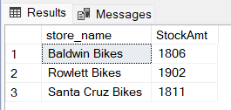

**Problem 7:** Create a stored procedure that lists the average, standard deviation, maximum, and minimum list prices for a specified bike brand. The output must show the brand name along with the aggregated results. The results need to be presented in ascending order based on the store name. The skeleton of the stored procedure is provided below.

USE BikeStores

CREATE PROCEDURE GetBrandListPriceStatistics

@BrandName VARCHAR(255)

AS

SELECT brand_name,

AVG (list_price) AS PriceAvg,

STDEV(list_price) AS PriceStdDev,

MAX (list_price) AS PriceMax,

MIN(list_price) AS PriceMin

FROM Production.products PR

INNER JOIN Production.brands BR

ON PR.brand_id = BR.brand_id

WHERE brand_name = @BrandName

GROUP BY brand_name;

EXEC GetBrandListPriceStatistics @BrandName='Trek';

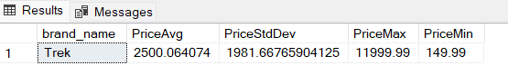

**Problem 8:** Create a stored procedure that lists the bike categories with minimum list prices below a specified value. The output must show the bike category and associated minimum list price. The results need to be presented in ascending order based on the bike category. The skeleton of the stored procedure is provided below. (Hint: The HAVING clause needs to be used.)

USE BikeStores

CREATE PROCEDURE GetBikeCategoriesWithMinPriceBelowValue

@Price DECIMAL(10,2)

AS

SELECT category_name, MIN(list_price) AS MinListPrice

FROM Production.Products PR INNER JOIN Production.Categories CA

ON PR.category_id = CA.category_id

GROUP BY category_name

HAVING MIN(list_price) <= @Price

ORDER BY category_name;

EXEC GetBikeCategoriesWithMinPriceBelowValue @Price=500;

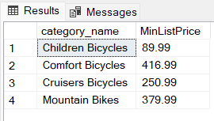

**Problem 9:** Create a stored procedure that lists the stock quantity for each bike category at a specified store. The output must show the bike category and stock quantity value. The results need to be presented in ascending order based on the bike category. The skeleton of the stored procedure is provided below.

USE BikeStores

CREATE PROCEDURE GetCategoryStockQuantityForStore

@StoreName VARCHAR(255)

AS

SELECT category_name, SUM(quantity) AS NumBikes

FROM Production.categories CT INNER JOIN Production.products PR

ON CT.category_id = PR.category_id

INNER JOIN Production.stocks SK

ON PR.product_id = SK.product_id

INNER JOIN Sales.stores ST

ON SK.store_id = ST.store_id

WHERE ST.store_name = @StoreName

GROUP BY category_name

ORDER BY category_name;

EXEC GetCategoryStockQuantityForStore @StoreName='Santa Cruz Bikes';

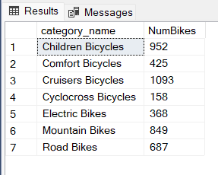

**Problem 10:** Create a stored procedure that presents the sales discount average and standard deviation for bike brands at or above a specified discount value. The output must show the brand names in alphabetical order along with the associated statistics. The skeleton of the stored procedure is provided below. (Hint: The HAVING clause needs to be used.)

USE BikeStores

CREATE PROCEDURE GetBrandAverageSalesDiscountAboveValue

@Discount DECIMAL(4,2)

AS

SELECT brand_name,

AVG(discount) AS DiscAvg,

STDEV(discount) AS DiscStdDev

FROM production.brands BR INNER JOIN production.products PR

ON BR.brand_id = PR.brand_id

INNER JOIN Sales.order_items OI

ON PR.product_id = OI.product_id

GROUP BY brand_name

HAVING AVG(discount) >= @Discount

ORDER BY brand_name;

EXEC GetBrandAverageSalesDiscountAboveValue @Discount=0.11;

